|  |  |
| --- | --- |
| EGC_Black | Student Name \_\_\_\_\_\_\_\_\_\_\_\_\_\_\_\_\_\_\_\_\_\_\_    **Eastern Goldfields College**  Mathematics Applications 2017  Test 2 – Calculator Assumed1 |
|  | Total Marks: 47 marks |

**Time allowed: 52 minutes**

**Calculator and one A4 notes permitted for this section.**

***Answer all of the following questions. Show all working to obtain full marks.***

**Question 1. [7 marks – 2, 2, 3]**

Calculate the value of the unknown in each of the following triangles.

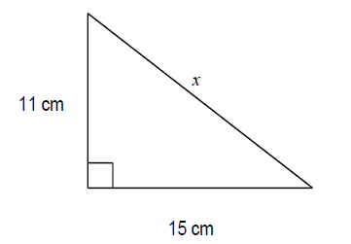 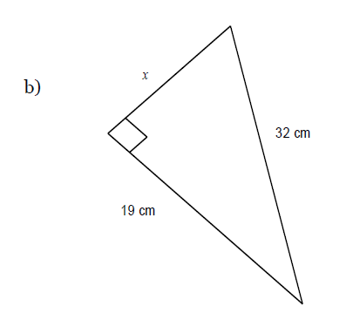

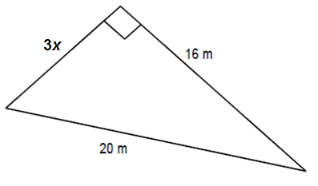

**Question 2. [6 marks – 3, 3]**

Calculate the perimeter of the following shapes. Diagrams are NOT to scale.

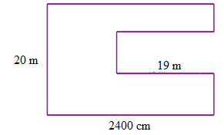

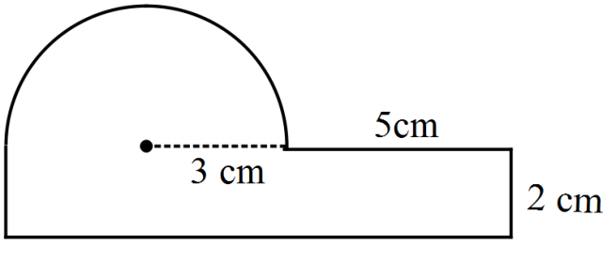

**Question 3. [5 marks – 3, 2]**

1. Calculate the area of the following shape.

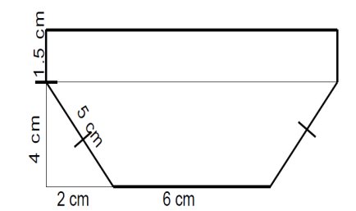

1. A rectangle’s height is twice the length of its base. If it has a height of 10 cm, calculate its area.

**Question 4. [3 marks: 1, 2]**

Cadel is going for a casual Sunday cycle. He cycles 20 km due north and stops to have a coffee at a café. Then he cycles 17 km due west to practice his sprints. He then returns directly back home.

i) Draw a labelled diagram to show Cadel’s cycle path.

ii) How much shorter is the ride home?

**Question 5. [2 marks]**

Franky has built a sand castle which is a cube on top of a cube. The large cube has faces 15 cm by 15 cm and the small cube is a cube of black beech wood she found on the beach. The length of one side of the black beech is 5 cm.

Calculate the volume of the sand castle, including the black beech wood.

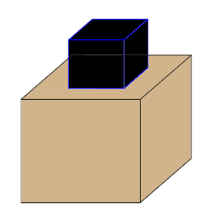

**Question 6. [2 marks]**Calculate the surface area of this dice if each face is 2 cm by 2 cm.

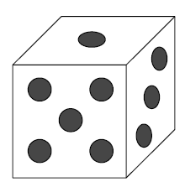

**Question 7. [2 marks]**

This is a picture of Tupperware’s newest picnic salad bowl. It is a hemisphere in shape and has a radius of 10 cm.

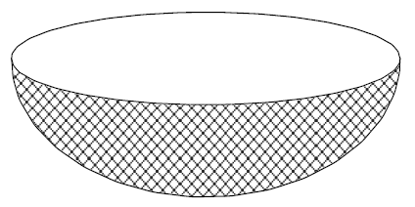

There are various colours to choose from for the **outside pattern** and this is printed onto the outside of the plastic bowl. Calculate the surface area of this **coloured print**.

**Question 8. [5 marks: 2, 1, 2]**

The official diameter of a tennis ball, as defined by the International Tennis Federation, is 6.54 cm. A standard tennis ball container is a cylinder in shape and snuggly fits three tennis balls so that the diameter of the cylindrical container is also 6.54 cm and the height is the exact height of the three tennis balls (spheres) inside.

a) Calculate the volume of the container.

**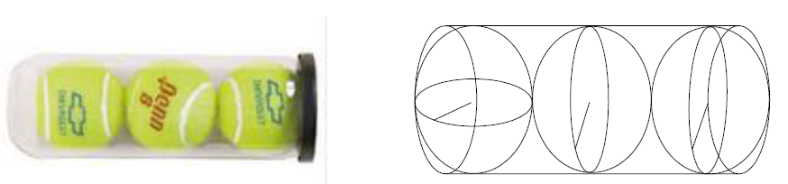**

b) Calculate the volume of one tennis ball.

c) Determine the volume of empty space inside the container

**Question 9. [5 marks: 2, 3]**

These delicious double choc waffle cones have chocolate in the bottom of the cone and an outer coating of chocolate. When they are being made the chocolate is poured into the cone up to exactly 1/3 of the height of the cone.

**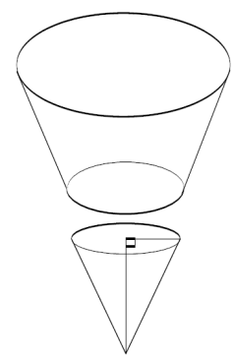**

a) If the radius of the cone is 30 mm and the height is 100mm, calculate the total volume of the cone, including the chocolate.

b) Calculate the surface area of the **cone to** be covered in chocolate if it is to be dipped in chocolate to cover the **entire** **outside** surface.

**Question 10. [5 marks: 4, 1]**

Aqua Delux swimming pools all have the same basic design as shown in the diagram below. Their design is fairly standard and most aspects are fixed. All of their pools are rectangular in shape and are 3 m by 6 m. They all have a shallow end which is always 0.9 m deep and the slope from the shallow end to the deep end is always 2/3 of the length of the pool. Where the pools may vary in their design is in the depth of the deep end. The minimum depth of the deep end is 1 m.

6 m

1. 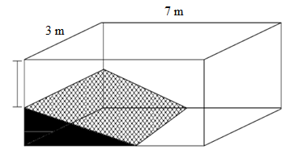Calculate the volume of water in the pool when   
    the deep end is 2 m deep.

b) What is the capacity of the pool when it is full to the top? \_\_\_\_\_\_\_\_\_\_\_\_\_\_\_\_\_\_\_\_\_

**Question 11. [5 marks]**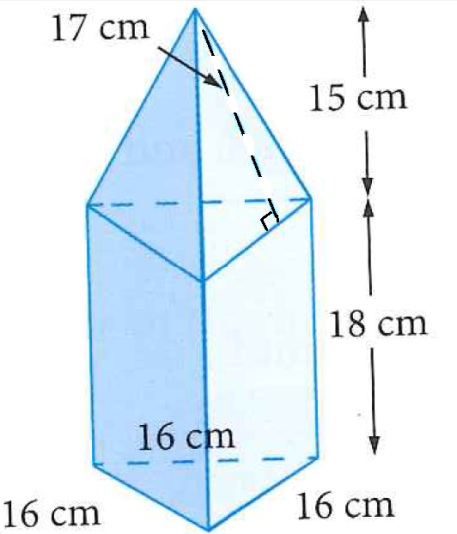This foam structure is part of a child’s toy. The dimension are shown in the diagram on the right. It consists of two sections: a triangular pyramid and a triangular prism sewn together. The faces need to be covered in fabric. Calculate the total amount of fabric required to completely cover the outside of this foam structure.

**~ END OF TEST ~**